COMPOUND FUNCTIONS
Pearson Edexcel - Tuesday 19 May 2020 - Paper 1 (Non-Calculator) Higher Tier
1.
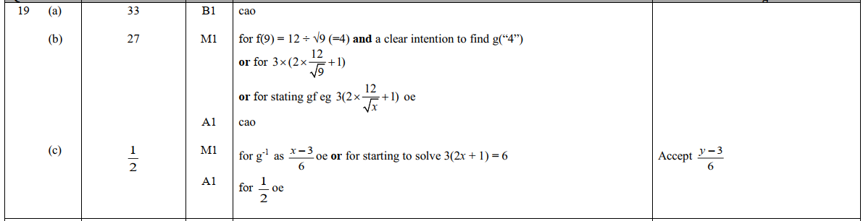

Pearson Edexcel - Tuesday 21 May 2019 - Paper 1 (Non-Calculator) Higher Tier
2.
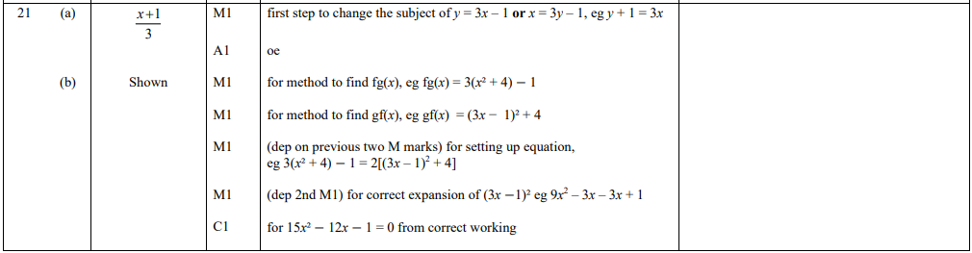
Pearson Edexcel - Tuesday 6 November 2018 - Paper 1 (Non-Calculator) Higher Tier
3.
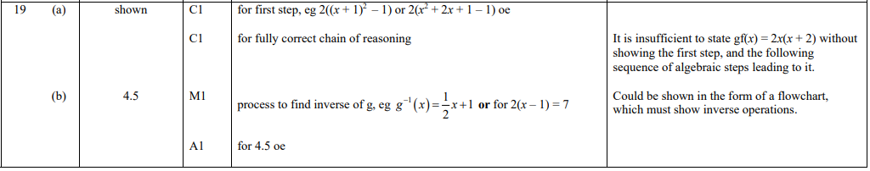
Pearson Edexcel - Monday 12 November 2018 - Paper 3 (Calculator) Higher Tier
4.
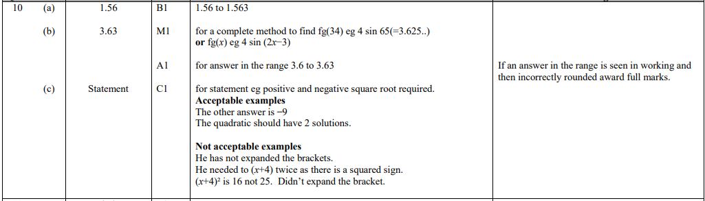
Pearson Edexcel - Thursday 7 June 2018 - Paper 2 (Calculator) Higher Tier
5.
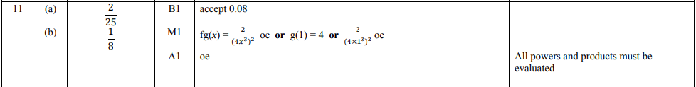
Pearson Edexcel - Monday 6 November 2017 - Paper 2 (Calculator) Higher Tier
6.
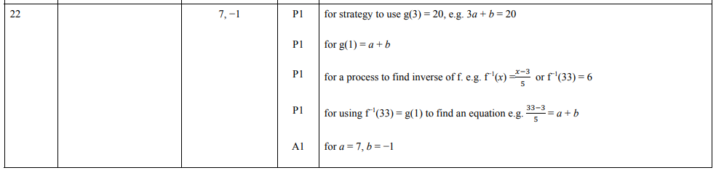
Pearson Edexcel - Specimen Papers Set 2 - Paper 2 (Calculator) Higher Tier
7.
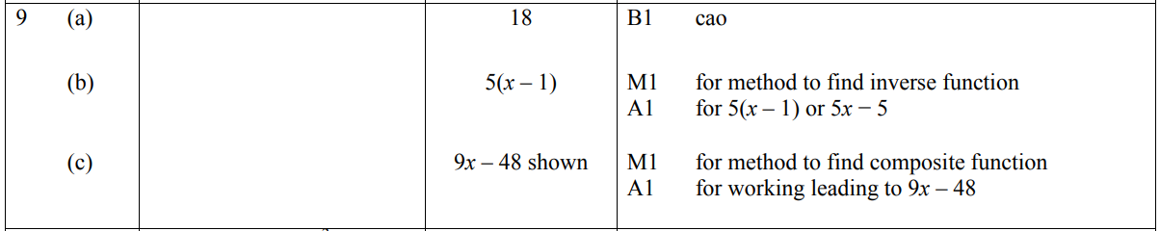
Pearson Edexcel - Specimen Papers Set 1 - Paper 2 (Calculator) Higher Tier
8.
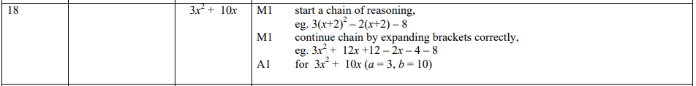

Pearson Edexcel - Sample Paper 3 - (Calculator) Higher Tier
9.
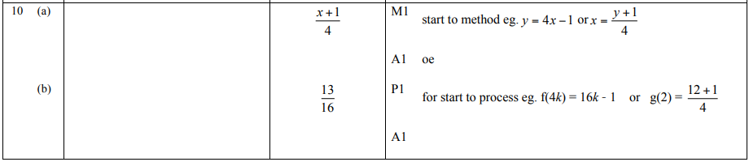
10.

